**FRAMBuilder 2.0**

**Program documentation & processing steps for preparing coded-wire tag data for Chinook FRAM base period calibration**

**The Chinook FRAM Base Period Workgroup, June 2016**

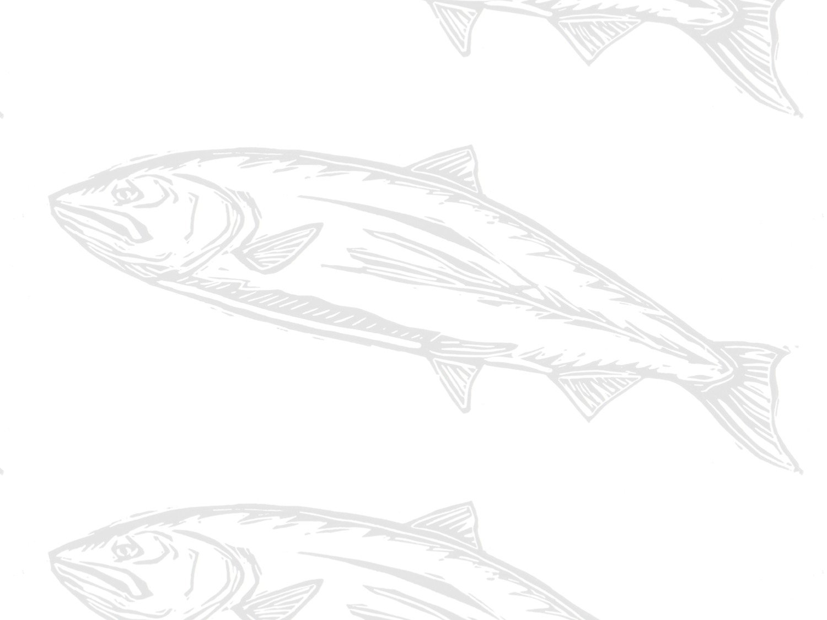

Contents

**1.** **Background and purpose** 2

**2.** **Overview of the process** 3

**3.** **Required programs and data files** 4

**4.** **Step 1: Select tag groups** 5

**5.** **Step 2: Query RMIS for release/recovery data** 6

**6.** **Step 3: Filter RMIS data for importing to CAS** 9

**7.** **Step 4: Load filtered CWT data into CAS** 10

**8.** **Step 5: Run FRAMBuilder** 13

**9.** **Step 6: Export data** 20

**10.** **Other FRAMBuilder functions/features** 20

**11.** **Limitations to FRAMBuilder and opportunities for enhancement** 20

**Appendix A. CTC Filter Database Recoveries Query Details/notes** 21

**Appendix B. Overview of the FRAM-modified CAS database** 22

**Appendix C. Weighting algorithm for merging stocks within and across broods…** 22

**Appendix D. Notes and exceptions for specific stock and fishery processing** 22

1. **Background and purpose**

General purpose

Although the Regional Mark Processing Center’s (RMPC) Regional Mark Information System (RMIS) contains considerable information about the recovery of Chinook salmon with coded-wire tags (CWT), considerable processing must occur in order to translate this information into currency that’s meaningful within a FRAM base period (BP) calibration context. Firstly, individual tag groups must be associated with a specific FRAM model stock. Secondly, tags recovered at a particular location (indicated by RMIS location code), time, and using a particular gear, must be mapped to one of FRAM’s model fisheries and time steps. The FRAMBuilder program and workflow described here was developed to fulfill these needs, among others. For instance, the program, and companion FRAM-CAS database, was modified to facilitate the preparation of inputs for estimating the parameters of the von Bertalanffy growth functions used by FRAM.

The connection to CTC tools

Early in the development of FRAMBuilder and the overall CWT mapping workflow, the base period workgroup (BPW) identified distinct advantages/benefits to leveraging the Pacific Salmon Commission’s Chinook Technical Committee’s (CTC) CWT analysis tools (i.e., the Cohort Analysis System [CAS] mapping program and companion database) within a FRAM calibration context. The BPW ultimately decided to tie FRAMBuilder to the CTC world because this connection: (1) allows for the seamless integration of CTC ‘Auxiliary’ CWT files, agency-supplied/prepared files that supplement or correct known errors/gaps in RMIS’s CWT recovery information; (2) facilitates the efficient inclusion of screened/vetted CWT release groups (i.e., selected by CTC members with regional expertise) into the calibration database; and (3) increases the overlap in information driving models supporting the management decisions of the PSC, the Pacific Fishery Management Council (PFMC), and state–tribal co-managers. Additionally, given partial overlap in the fishery assessment units used by the CTC and in FRAM, the integration of CAS into the FRAM calibration workflow offered efficiency in the form of an initial stage of RMIS-to-FRAM mapping.

Document scope

This user’s manual is meant to serve two purposes. Firstly, it provides a roadmap of the process that gets one from raw RMIS CWT release/recovery data to something useable in a FRAM calibration. Secondly, it provides basic documentation on the structure/function of the FRAMBuilder program, its companion FRAM-CAS database, and the ruleset it follows to get CWT recoveries from the initial CAS stage of mapping to a final FRAM fishery/time step state. As for the tools ‘borrowed’ from the CTC (i.e., CAS.exe), we provide only a brief sketch here and refer the reader to CTC resources for further documentation.

1. **Overview of the process**

In concept, the procedures to map an individual CWT recovery to a FRAM stock and fishery are straightforward: (a) in screening candidate codes, make a determination regarding which tags are suitable representatives for model stocks, and (2) given recovery details, such as RMIS location codes, gear codes, dates, etc., make a determination regarding the model fishery/time step to which the recovery belongs. In practice, however, this task is extremely difficult given that thousands of tag codes (= unique release groups) are available for consideration, resulting in hundreds of thousands of individual tag recoveries that must be mapped from one of tens of thousands of unique location-gear code combinations to one of FRAM’s seventy-two model fisheries. The FRAMBuilder workflow, although cumbersome at first glance, boils this seemingly insurmountable challenge down to a task that can be achieved by one person in a relatively short amount of time (i.e., assuming that candidate codes have been selected and auxiliary files have been acquired/prepared). It commences according to the following steps (Figure 1), each of which will be described in gory detail further below:

1. Select tag groups.
2. Query RMIS for release/recovery data.
3. Load RMIS query results into the CTC Filter database, and query it to create CAS input files.
4. Load tags into CAS (i.e., stage 1 of mapping – to CTC fishery strata).
5. Run FRAMBuilder (i.e., map/process recoveries).
6. Export data for calibration input files.

In addition to these steps, a handful of other functions can be invoked during step 5, depending on a user’s needs. These are also described further below. The remainder of this document is organized around each of these steps, where each subsection offers both ‘how to’ details and documentation on processing decisions, algorithms, etc. where necessary.

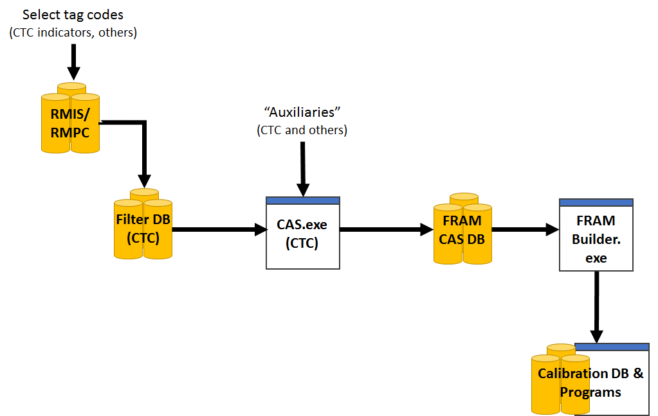

**Figure 2.1.** Relationships between the databases and programs used to construct FRAM base period calibration input files.

1. **Required programs and data files**

**Data files**

* **A list of tag codes:** A list of tag codes is needed for the purposes of querying RMIS (release/recovery), as well as for populating the CTC Filter database’s ‘STKCDS’ table.
* **CWT release data**: These are the raw release details for the chosen codes, acquired from RMIS via a ‘Tagged Releases’ query; query results are downloaded as a CSV, with the headings specified under Step 2 below.
* **CWT recovery data**: These are the raw recovery details for the selected codes, acquired from RMIS via a ‘Recoveries By Tag Code’ query; query results are downloaded as a CSV, with the headings specified under Step 2 below.
* **Auxiliary files (or ‘auxiliaries’):** These are text files (*.csv or *.txt), prepared by CTC members from a variety of agencies/jurisdictions, that contain supplementary CWT recovery information that is meant to augment (or revise) the CWT information acquired from RMIS for some stocks; these files are typically created on a stock/code basis and are necessary to ensure the calibration process includes the most accurate information. For example, CWT recoveries in escapement—a major anchor point for the type of backwards cohort reconstruction underlying FRAM calibration—are not available via RMIS for many Canadian stocks.

**Databases (all Microsoft Access)**

* **The CTC’s Filter Database:** This is a Microsoft Access database into which the RMIS release/recovery query results (above), combined with a tag list (‘STKCDS’) are loaded. Using two custom queries, this database returns RELEASES.txt and RECOVERIES.txt files which can be imported directly to the FRAM-CAS database.
* **A FRAM-modified CAS database (FRAM-CAS hereafter)**: This Access database is an adaptation of the CTC CAS database (final preseason 2013 version[1]), which includes several tables (and added fields to existing tables) designed to (1) cross-walk CTC fishery strata to FRAM fisheries or (2) to house/contain mapped outputs for direct export/use in CAS.

**Programs & companion files**

* **FRAMBuilder 2.0:** Because FRAMBuilder is very much an interactive program subject to ad hoc changes/revisions to fulfill the BP team’s evolving needs, it hasn’t yet been developed into a distributed, fully compiled .exe file (i.e., ‘production mode’). Thus, the ‘program’ is actually a Microsoft Visual Studio solution (.sln) file that is operated within the development environment (i.e., Visual Studio, version 2008+).
* **The CTC’s CAS (and dll)**: CAS1.5_No_Restrictions.exe and CASLib.dll (2013 versions)
* **Visual Studio, version 2008+**: To operate FRAMBuilder ‘in the environment’ you will need a compiler; Visual Studio Express for desktops is a good free option (if Professional isn’t on your list of programs).
* **Others**:Although they aren’t tied explicitly to the mapping procedures outlined here, there are both R and OpenBUGS programs that estimate parameters for growth functions from CWT length observations (i.e., mapped to FRAM fishery and size limit regulation) summarized by FRAMBuilder. Jon Carey also has an R program (and input template/files) that estimates missing recoveries for freshwater sport (Puget Sound, Willapa Bay tribs) and estuary sport (Willapa Bay).

1. **Step 1: Select tag groups**

Although the rationale surrounding the final decisions to include/exclude tag codes is beyond the scope of this document, here we outline the basic guidelines used to select the codes contained in the current calibration dataset. Firstly, we preferentially selected CWT codes associated with CTC ER indicator stocks given that CTC members with regional expertise have already screened what’s available to best represent natural and hatchery Chinook stocks within their jurisdiction. For stocks/regions beyond the CTC’s scope, selection was guided by the following criteria/considerations:

* For nearly all stocks, tag selection was limited to brood years (BY) 2005-2008; additional brood years were included for special calibration analyses (e.g., out-of-base procedures relied on brood years 2002-2004, growth functions); and, due to the ‘collapse years’, Sacramento/Central Valley fall Chinook include 2009 brood releases and omit 2005-08 broods.
* Only stocks belonging to the ‘5000’ series of marks (i.e., adipose-fin clipped) were included; unmarked fish could not be used due to their absence in (1) CWT samples for visually sampled fisheries and (2) mark-selective fishery catches.
* We generally avoided CWT release groups (1) from ‘experimental’ production groups (e.g., novel stock crosses), (2) with questionable warning flags (e.g., BKD outbreak), (3) that were released at stages earlier than the fingerling stage, and/or (4) that were released at locations with difficult/poor escapement enumeration (e.g., acclimation ponds).

For further detail on codes selected for particular stocks, please refer to the Chinook FRAM stock profile spreadsheet, available for download at: <https://github.com/petemchugh/FRAMBuilder/blob/master/2016ChinFRAMBP_StockProfiles012816_Protected.xlsx>.

1. **Step 2: Query RMIS for release/recovery data**

Given a set of codes, the next task is to query RMIS for the necessary release and recovery information. The online system is at <http://www.rmis.org/rmis_login.php?action=Login&system=cwt>, and requires that you have a user account. Release data are acquired via the ‘Releases: Tagged Releases’ query form, which requires your tag list. After entering the list of tags (Figure 5.1) and clicking ‘Retrieve’, you’ll have to choose the type of report (CSV in email or browser is preferred; Figure 5.2), and then specify what fields you’d like to see in the query results. For the purposes of loading the Filter Database, there’s a specific User List that you’ll need to use (Note: you can copy/paste the list from here):

tag_code_or_release_id

species

run

brood_year

release_location_code

first_release_date

last_release_date

cwt_1st_mark

cwt_1st_mark_count

cwt_2nd_mark

cwt_2nd_mark_count

non_cwt_1st_mark

non_cwt_1st_mark_count

non_cwt_2nd_mark

non_cwt_2nd_mark_count

hatchery_location_code

stock_location_name

related_group_type

related_group_id

Upon validating the user list and clicking the ‘Run’ button, results will be returned to your screen/email; these, less the junk header (browser report only) text that reads ‘You are here: Home > RMIS Standard Reporting > Query Results > Report CSV’ can be copied/pasted into a text editor and saved for importing to the Filter Database.

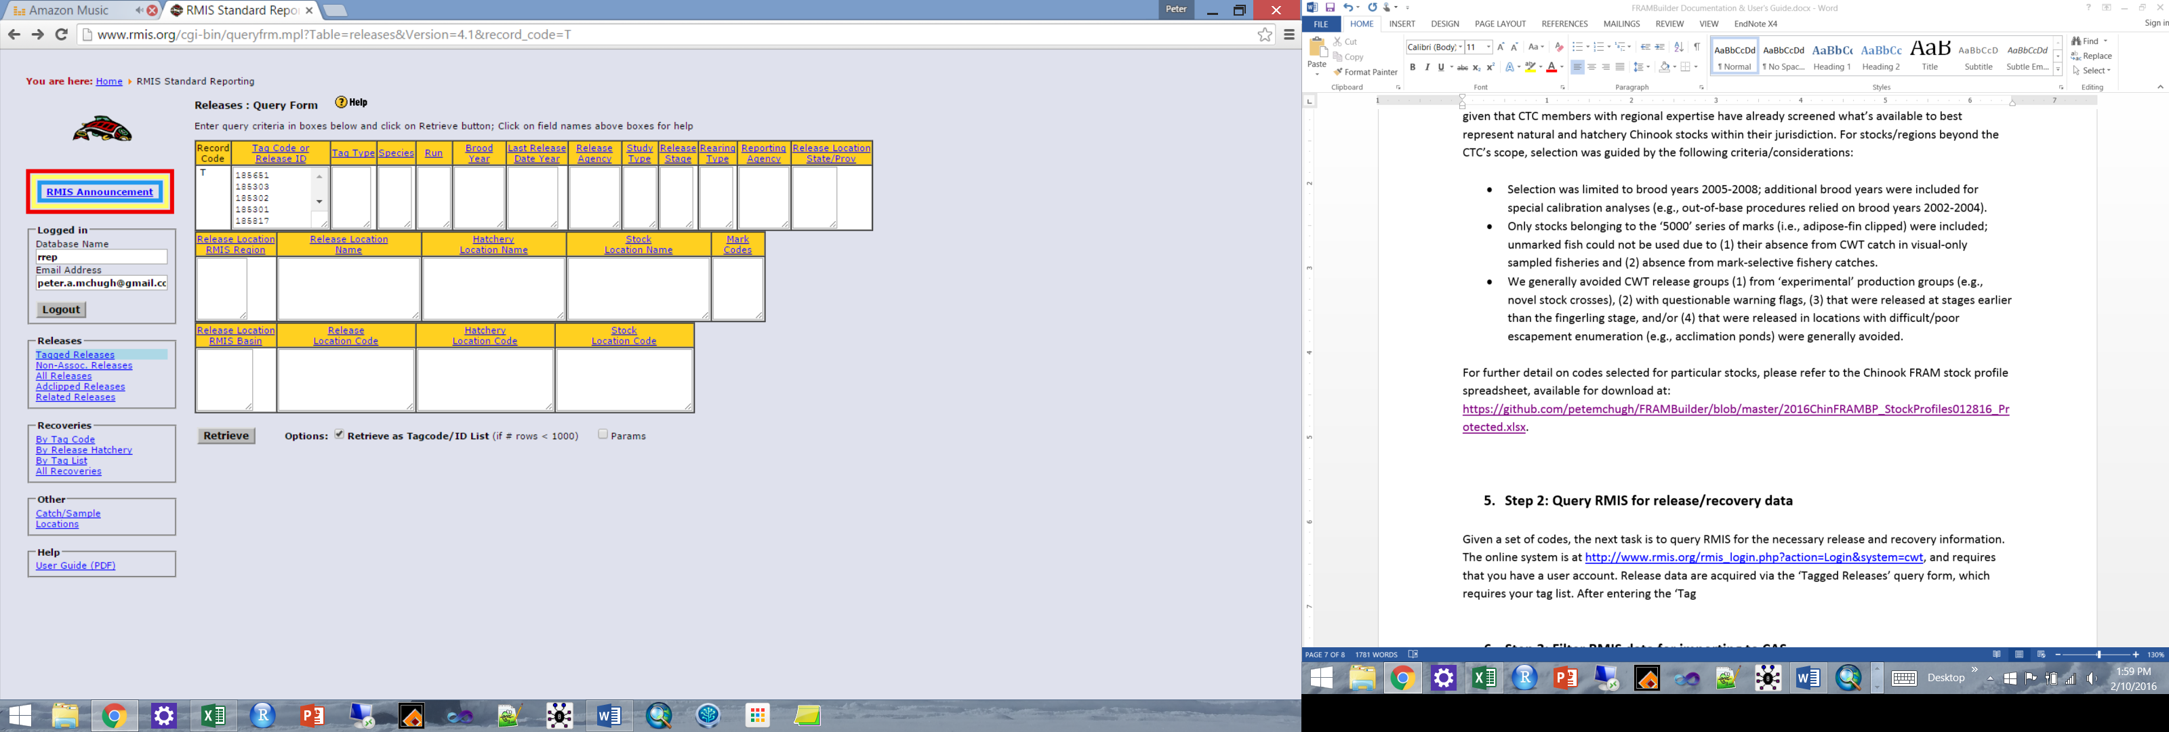

**Figure 5.1.** RMIS’s ‘Tagged Releases’ query form, wherein the set of codes desired is specified.

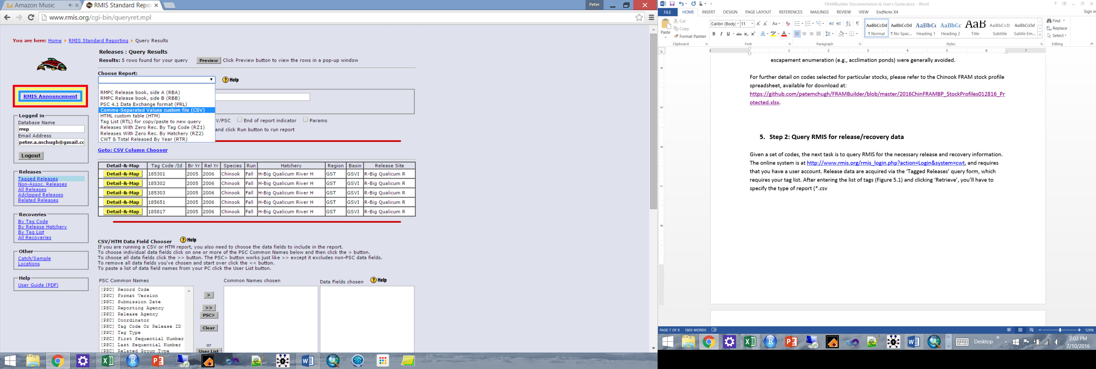

**Figure 5.2.** Form for specifying query result specs, specifically report type (CSV).

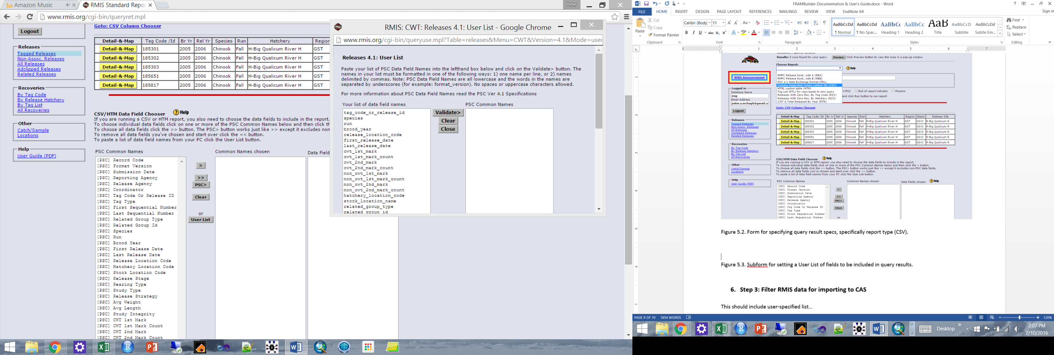

**Figure 5.3.** Sub-form for setting a User List of fields to be included in query results.

The steps followed for running the custom ‘Releases: Tagged Releases’ query are now repeated for the ‘Recoveries: By Tag Code’ query, only this time, the custom User List will include the following fields (NOTE: unlike releases, only 180 codes can entered here):

recovery_id

recovery_date

period_type

period

species

sex

length

length_code

tag_code

tag_status

estimation_level

recovery_location_code

fishery

estimated_number

sample_type

run_year

recorded_mark

catch_sample_id

detection_method

sampled_maturity

reporting_agency

adclip_selective_fishery

Query results can now be saved as a CSV imported into the Filter Database. Because it will take multiple queries to get release information for the 700+ CWT codes included in the FRAM calibration dataset, be sure to save these with clearly defined names or append them to a single, growing CSV (be sure to remove column headings if you append output). Also, be careful when opening/viewing these query results before importing into Filter Database; CSVs open readily in Excel and can be unintentionally reformatted upon opening (e.g., text to numeric will drop leading zeros on some codes).

1. **Step 3: Filter RMIS data for importing to CAS**

The release and recovery CSV files constructed in Step 2 can now be imported directly into the Filter Database. This is achieved via the Microsoft Access functions under External Data > Import & Link > Text File. This allows you to specify the appropriate Releases.CSV or Recoveries.CSV file in the ‘File Name field’ (browse and point to accordingly) and append records to the appropriate database table (RELEASES or RECOVERIES). To minimize potential error, it is generally advisable to start with a clean Filter Database for these steps.

After loading RMIS query results, the Filter Database’s ‘STKCDS’ table (Figure 6.1) must be populated with the tag codes contained in the release and recovery datasets. The three letter abbreviations in the STOCK field must follow existing conventions (i.e., be in the CAS ‘SpeciesStock’ table), otherwise records will be rejected [Note: although all FRAM stocks are already covered, new stocks can be added via steps contained in CTC CAS help files].

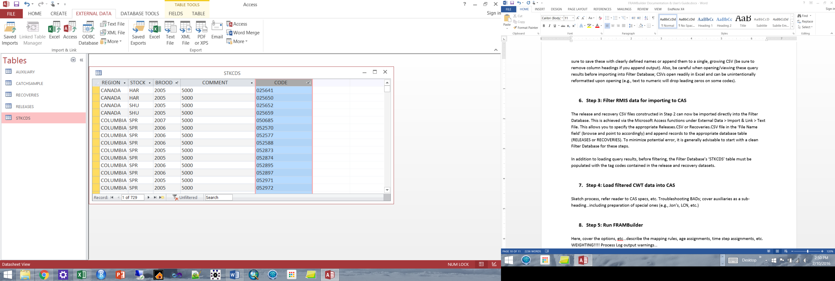

**Figure 6.1.** The Filter Database’s ‘STKCDS’ table, which requires jurisdiction, stock acronym, brood, marking, and CWT code information.

After the Filter Database is loaded with necessary content, these data are ‘filtered’ via two queries (releases, recoveries) that are saved as .txt files for importin to CAS via. The ‘ERARECOVERIES’ filter query eliminates (1) recovery observations that cannot be used in a quantitative analysis (i.e., RMPC ‘sample type’ = 5), (2) high seas fishery recoveries, and (3) some recoveries that are dealt with as auxiliaries (e.g., Canadian escapements); see **Appendix A** for SQL query details. The ‘ERARELEASES’ filter query, in contrast to recoveries, does minimal joining (STKCDS to Releases) and reformats the release data in prep for CAS import. Step 3 should yield two text files, ERARELEASES.TXT and ERARECOVERIES.TXT (you save under different names as you see fit).

1. **Step 4: Load filtered CWT data into CAS**

Using the CAS1.5_No_Restrictions.exe program (CAS program or CAS.EXE hereafter), the ERARELEASE.TXT and ERARECOVERIES.TXT files will can now be imported into the FRAM-CAS database. Depending on the application, you may want to first clear out the entire FRAM-CAS database, using the CAS program (Figure 7.1). First, however, you must connect your CAS program to the FRAM-CAS database with which you’re working (you will be prompted to do so upon opening the program). Once connected, you can clear things out as needed (Figure 7.1) and then you’re ready to import filter database output releases (Figure 7.2), recoveries, and/or any auxiliary files (discussed further below). The procedure for each file type is the same, you first point the program to the appropriate release, recoveries, or auxiliary text file (.TXT or .CSV) and menu, then you click ‘Load’ and wait for the process to complete. Once CAS has finished loading the data, you should examine the running CAS error log (‘CASErrors.TXT’, this is written where the program occurs) and the ‘*.BAD’ (a text file) associated with each input you’ve attempted to load—these will tell you which (if any) records were rejected and offer you clues regarding why this occurred.

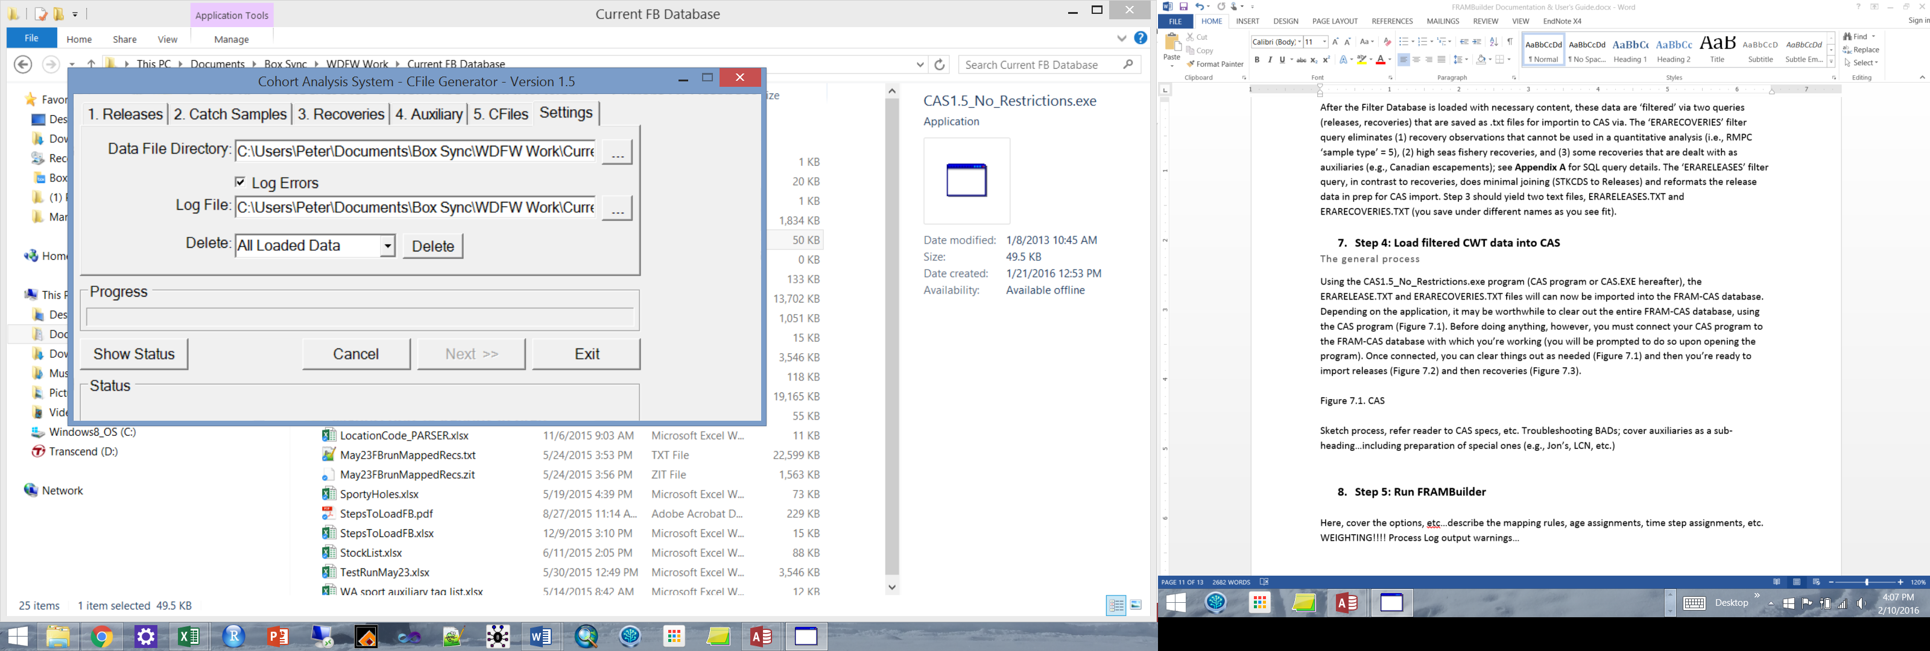

**Figure 7.1.** The CAS program’s Settings menu, the location in which loaded data can be deleted.

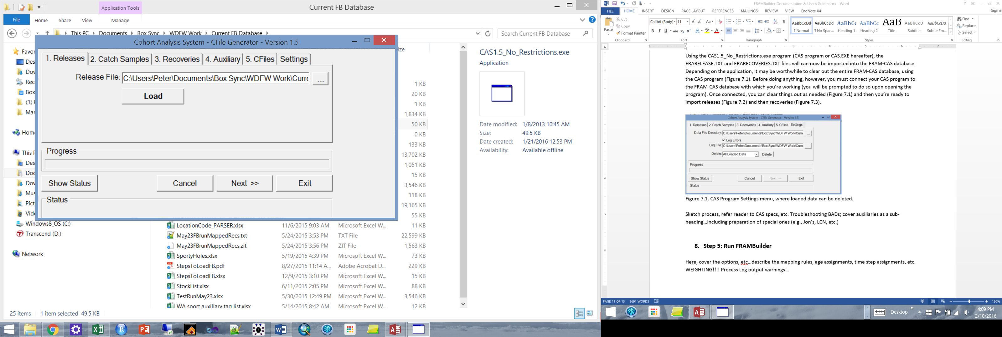

**Figure 7.2.** The CAS program’s Releases loading menu.

Troubleshooting rejected releases and recoveries

Typically a handful, but sometimes many, records will be rejected during the FRAM-CAS database loading process. This can feel like the most cumbersome step of the FRAM-CAS database loading process, but with some patience and insight is relatively easy to work through. The problems and solutions include (*solution in italics*):

1. For releases, this can arise because the stock code isn’t included in the ‘SpeciesStock’ database table (this shouldn’t happen, but if it does, see CTC help file guidance); *upon adding the new stock’s details, it should load correctly*.
2. For recoveries, the recovery location may not be parsing in such a way that can get a recovery from an RMIS location code all the way to a CTC fine-scale fishery; *in this case, you’ll have to manually add a parsed location (with fine-scale fishery mapping) to the FRAM-CAS database ‘FisheryLookup’ table*, *and reload the associated BAD records*; e.g.: RMIS Location Code: “3F10510 080122 R” parses to the fields in green, and you must supply the red info (Fishery = CTC Fishery Stratum, CWDBFishery = RMIS Gear Code, Species = 1 for Chinook; gray fields can be left empty):

|  |  |  |  |  |  |  |  |  |  |  |  |  |  |  |  |  |  |  |
| --- | --- | --- | --- | --- | --- | --- | --- | --- | --- | --- | --- | --- | --- | --- | --- | --- | --- | --- |
| Id | Fishery | CWDBFishery | StateProvince | WaterType | Species | Stock | Sector | Region | Area | Location | SubLocation | StartMonth | StartDay | EndMonth | EndDay | F17 | F18 | F19 |
|  | 1079 | 54 | 3 | F | 1 |  | 1 | 05 | 10 | 080122 | R |  |  |  |  |  |  |  |

The parsing rules from RMIS Location Code to field values are: Char(1) = StateProvince; Char(2) = WaterType; Char(3) = Sector; Char(4-6) = Region; Char(7-9) = Area; Char(10-16) = Location; Char(17-19) = Sub-Location.

1. In other cases, the recovery location might be parsing correctly, but a fishery really isn’t part of the FRAM (or CTC universe). In rare cases, for example, Chinook FRAM’s stocks have been recovered in net fisheries in Cook Inlet and Prince William Sound. *These rarities are not included* *and treated as though they’re ‘natural mortality’*.
2. On rare occasions, RMIS contains records with a valid sample type, but no ‘estimated number’ for a particular tag recovery. *In these cases, the user must decide what to do, i.e., to enter a value or omit altogether.* For example, if it’s likely a data error and in fact each fish represents an individual (e.g., censused escapement at a hatchery), then these records could be given an estimated number of 1.0 and reloaded. It is on the BP team, however, to make the call given whatever information is available (regional expertise/contacts, etc.).
3. A portion of the auxiliary data you’re supplying isn’t part of the tag set of interest. For example, a CTC member from Canada may supply escapements for all of their stocks for all years in a single file, whereas you’re only interested in 2005-2008 broods. *If this is the basis for rejection, there’s nothing more that you need to do*.

The good news is that, generally speaking, once a solution to a parsing problem or release rejection problem is resolved in the FRAM-CAS database, it will address all future instances subject to the same circumstances (and/or future reloads).

What are auxiliaries?

As noted above, so-called auxiliary CWT recovery files are also loaded into the FRAM-CAS database during this stage of the overall process, and are denoted as such in the ‘CWDBRecovery’ table (‘Auxiliary’ = T/F field). These files, which are supplied by regional experts who steward CWT recovery data for particular stocks or fisheries, are meant to either augment or correct the data acquired via RMIS for the tag groups in question. While the deficiencies/errors in RMIS content and/or the basis for auxiliary file creation are beyond the scope of this manual, these files are needed to ensure that all observations of tagged model stock cohorts are correctly captured in the FRAM BP dataset. Because these datasets are routinely updated, it is important to acquire the latest[2] versions from the appropriate CTC point(s) of contact prior to completing a full FRAM-CAS loading process. Finally, similar input files may need to be created for any non-CTC stocks necessitating similar supplementary or revisionary data (e.g., for unsampled freshwater sport fisheries in Willapa Bay).

For further documentation on the CAS program and database, see the design specs document prepared by Wostman and Associates, Inc. for ADFG and the CTC (<https://github.com/petemchugh/FRAMBuilder/blob/master/CTC%20CAS%20Documentation/CAS%20Design%20Spec.doc>). For more information on the FRAM-CAS database, and more specifically how it has been modified to integrate FRAM functionality, see **Appendix B**.

1. **Step 5: Run FRAMBuilder**

Now that tags the FRAM-CAS database has been successfully loaded with the CWT data needed for running the BP calibration, we have just a few additional (albeit very important) steps to (1) complete the RMIS to FRAM fishery mapping work, (2) process the selected tags/broods for the selected stocks so they correspond to a single ‘super code’, and (3) format and write calibration input files to the FRAM-CAS database. This section covers the rationale and sequence of steps to follow in order to complete this process.

Mapping/adjustment rules

Before diving into the ‘how to’ details, here we provide a brief overview of the main rules/processing tasks that FRAMBuilder executes to map CWT recoveries from CAS fishery purgatory to the final FRAM fishery/time step/age stratum (see the subroutine ‘BGworker_output_DoWork’ in ‘OutputOptions.vb’ for further detail) [Note, whenever any of the special processing rules summarized below is applied to a particular recovery, a record detailing the adjustment is added to the FRAM-CAS database’s ‘FRAM_ProcessLog’ table]

1. Split CAS Washington Coast Troll fisheries (fisheries 16/17 for Areas 3/4/4B, 20/21 for Area 2) into their respective treaty/non-treaty components based on fishery code (10 vs. 15).
2. Split CAS Washington Coastal Rivers Net into FRAM Grays, Willapa, and North Washington Coast components; this is achieved based on RMIS Recovery Location Codes.
3. Split CAS Georgia Strait Sport into FRAM North Geo Str (stat areas 13-16), South Geo Str (17-18, 19A, 28-29), and Juan de Fuca (19B, 20) sport; this is done using the RMIS Recovery Location Code and Canada DFO stat areas.
4. Split CAS Washington SPS Net into FRAM’s 13A and SPS (13/13D-K) Net; this is done using the RMIS Recovery Location Code.
5. Split CAS Washington 10/11 Net into FRAM 10A, 10E, and 10:11 Net; this is done using the RMIS Recovery Location Code.
6. Split CAS Washington Area 10 sport into FRAM 10A, 10E, and 10 sport; this is done using the RMIS Recovery Location Code; NOTE, due to errors in data coding and an inability to accurately parse 10A/E from general 10 during summer MSFs, as well as generalized regulations during Oct-Jun, this processing step is only applied during months outside of July-Sept.
7. Assign summer recoveries mapped to CAS Washington Area 8 to FRAM 8D sport (Tulalip Bay) (general 8 is closed to Chinook retention and CAS doesn’t distinguish).
8. Parse CAS combined 8A/8D net into separate FRAM 8A and 8D fisheries; this is done using the RMIS Recovery Location Code.
9. Separate the KMZ component of CAS’s California Troll and assign it to KMZ troll; this is done using the RMIS Recovery Location Code.
10. Separate the KMZ component of CAS’s California Sport and assign it to KMZ sport; this is done using the RMIS Recovery Location Code.
11. For Hoodsport terminal marine net and sport, map catch to the equivalent ‘freshwater’ fisheries;
12. Correct Area 1 troll recoveries that were inadvertently mapped to Oregon Area 3; I believe that this has been resolved in RMIS, but if not errors will be corrected in FRAMBuilder.
13. Separate the combined Bellingham Bay treaty/non-treaty net fishery recoveries into separate treaty/non-treaty components. Unfortunately, this ‘processing rule’ can’t be fully implemented in code because a non-distinct (indiscernible treaty/non-treaty) fisher type/gear code precludes assignment with certainty. Thus, the data are pre-processed externally (e.g., within the file ‘BellinghamBayEvaluation(May2016_Split).xlsx’) to make individual tag ‘Tr/NT’ assignments based on fisher type/gear codes in RMIS and/or annual treaty/non-treaty catch fractions (see appendx X). Given this pre-processing step, FRAMBuilder then places recoveries in the appropriate FRAM fishery based on the values added to the CWDBRecovery field called ‘Tr_NT’.
14. Map all freshwater recoveries, i.e., sport, net, B10 sport, Col R Net, escapement, to the escapement fishery (fishery 74); this is step allows for calibrations in terms of ETRS as desired under the new BP framework (note, a new output field that allows identification can be added as needed).
15. Make and modify time step (TS) assignments as needed; time step assignments are done initially based on the calendar month in which recoveries occurred (<4 & >=10 is TS1; 5&6 = TS2; 7-9 = TS3), but in several instances things will have to be shifted slightly. For instance, since fall Chinook are only allowed to mature in TS3, recoveries in freshwater sport/escapement/net during TS1/4 are shifted to TS3.
16. Determine the FRAM age equivalent for each fish. This initially assigns age as ‘run year – brood year’ and then adjusts as needed to reflect the fact that (a) fish have birthdays on Oct 1, (b) Willamette and Cowlitz/Kalama/Lewis spring Chinook (yearling releases) are to be treated as true age - 1 in FRAM[3], and (c) fish aren’t allowed to be younger than age 2 or older than age 5.

Merging & weighting

Beyond applying mapping/adjustment rules, a secondary function of FRAMBuilder is to merge CWT data for a given stock within selected BP broods and ultimately across broods to create a synthetic all-broods ‘super code’. The program is flexible and can accommodate a few different merging approaches. Within brood years, merging is either done (1) on an unweighted basis (default) or (2) using user-specified weights which have to be entered on a stock/code/BY basis in the ‘FRAM_Weights’ table. The first option simply treats all CWT releases as though they’re equivalent and lumps together accordingly. The latter option allows users to specify weights according to any rationale. For example, the Skagit spring yearling model stock is actually a mixed fingerling/yearling stock for which user-supplied weights have been developed to create a 50:50 representation of the two life history variants in a single, composite stock when merged within BYs. After merging within BYs, FRAMBuilder merges CWT recoveries across BYs according to one of three approaches (1) unweighted merging, (2) recoveries-weighted merging (the default), or (3) user-specified weighting[4]. The default recoveries-weighted algorithm is designed to rescale recoveries (i.e., *R’*FAT-*b* = *Wb*\**R*FAT-*b*) within each brood year so that all brood years have equal influence on the calibration dataset, i.e., for brood year *b* the weighting/scaling factor (*Wb*) is computed as *Wb* = max(*Rb*) / *Rb*, where *Rb* = *R*FAT-*b* and *Rb* and *R*FAT-*b* are the estimated recoveries total for brood year *b* and the fishery-age-time step-specific recoveries total within brood year *b*.

Output file creation and database population

Once data processing is complete, FRAMBuilder writes several results to the FRAM-CAS database, with specific RunID attribution (a unique date-time based stamp). The main outputs of interest are:

1. The ‘FRAM-OUT_CWTAll’ table; this contains the results for the processing run in a format (merged, etc.) that can be fed directly into the main calibration program[5].
2. The ‘FRAM_star_CWT’ table; this contains mapped/summarized results for various stages in the processing sequence, i.e., mapped stock-fishery-age-TS totals by code (indicated by raw code ID), by BY (X*yy*.STK where *yy* and STK are the BY and 3-letter stock ID), and ‘super code’ (AB*mm*.STK where *mm* is the merging method ID and STK is as above)
3. The ‘FRAM_ProcessLog’ table contains info about what special rules (listed above) were invoked in a given processing run for a particular recovery ID;
4. The ‘CWDBRecovery’ table, the main recovery table feeding the entire process, has a field (‘finalFmap’) that gets populated with the numerical ID for the fishery to which a given recovery was ultimately mapped; this result is quite useful for both error checking and post-run summarization (e.g., for other purposes).
5. If summary files for estimating growth functions is necessary (and the necessary processing option invoked), FRAMBuilder will also write results to ‘FRAM_GrowthData’;
6. If old school outputs are needed (e.g., *.CWT files, text based process logs, etc.), the checkbox allowing for this feature will need to be reactivated.

Running the full processing sequence

First, open the FRAMBuilder program (i.e., run it in debugging mode once you’ve opened the VB.NET solution) and connect it to your FRAM-CAS database by clicking ‘Select CWT Database’ when you reach the Welcome Screen (Figure 8.1).

Second, once you’ve connected, click the second button (‘Select and View CWT Data’) on the welcome screen. This will take you to a form in which you’ll actually choose the specific CWT codes that you’re interested in mapping/processing for the calibration process (Figure 8.2). Upon selecting desired codes/stocks via this screen, you’ll get a chance to view raw recovery data (click ‘Import and view’ upon selecting) prior to initiating the processing sequence. The next window (Figure 8.3) will show you the raw recoveries, which are now queued for processing; click ‘Confirm selection’ to return to the main meu, from where you’ll navigate to the processing menu by clicking ‘Set Output Options and Run’ (Figure 8.1).

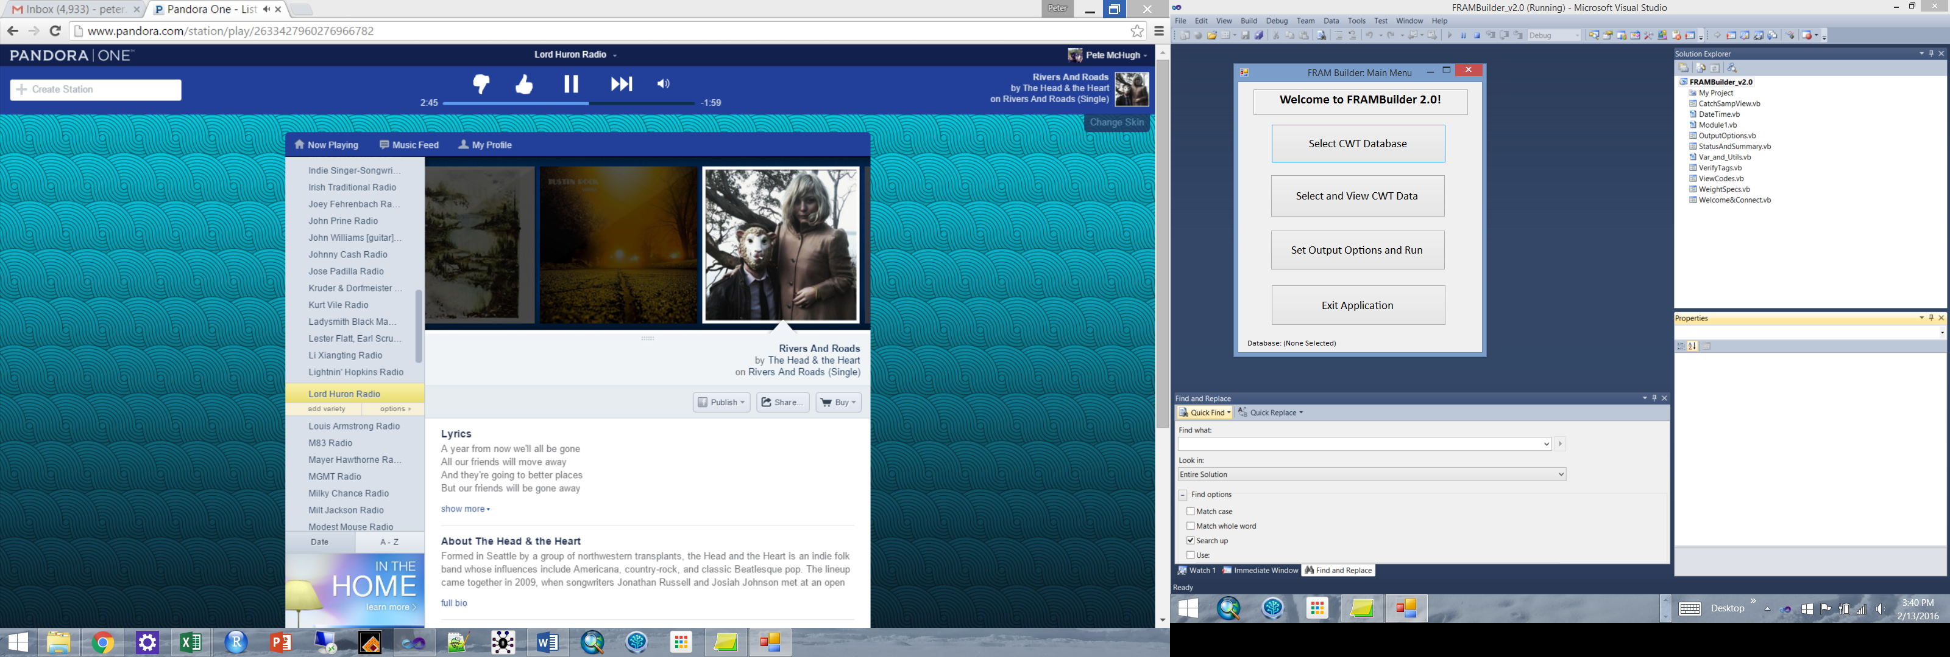

**Figure 8.1.** FRAMBuilder welcome screen. Before doing anything you must select your database (uppermost button), from there the process follows sequentially down the list.

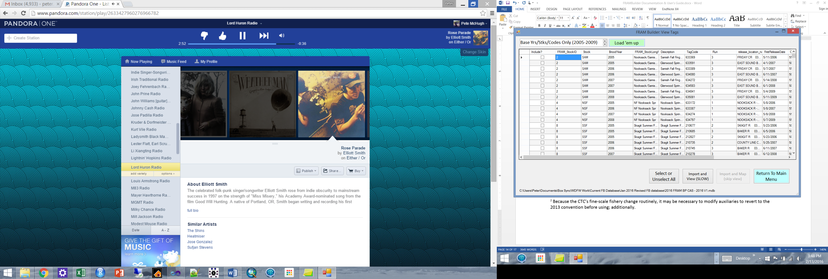

**Figure 8.2.** FRAMBuilder tag selection screen. Upon reaching this screen, the subset (if appropriate) of tags contained in the database desired for viewing/editing must be selected using the toggle list and ‘Load ‘em up’ button. Thereafter, selecting particular codes is achieved by clicking check boxes (leftmost column, ‘Include?’) or by clicking select/unselect all. Thereafter, the FRAM-CAS database will be queried for the relevant content, which you can view prior to processing.

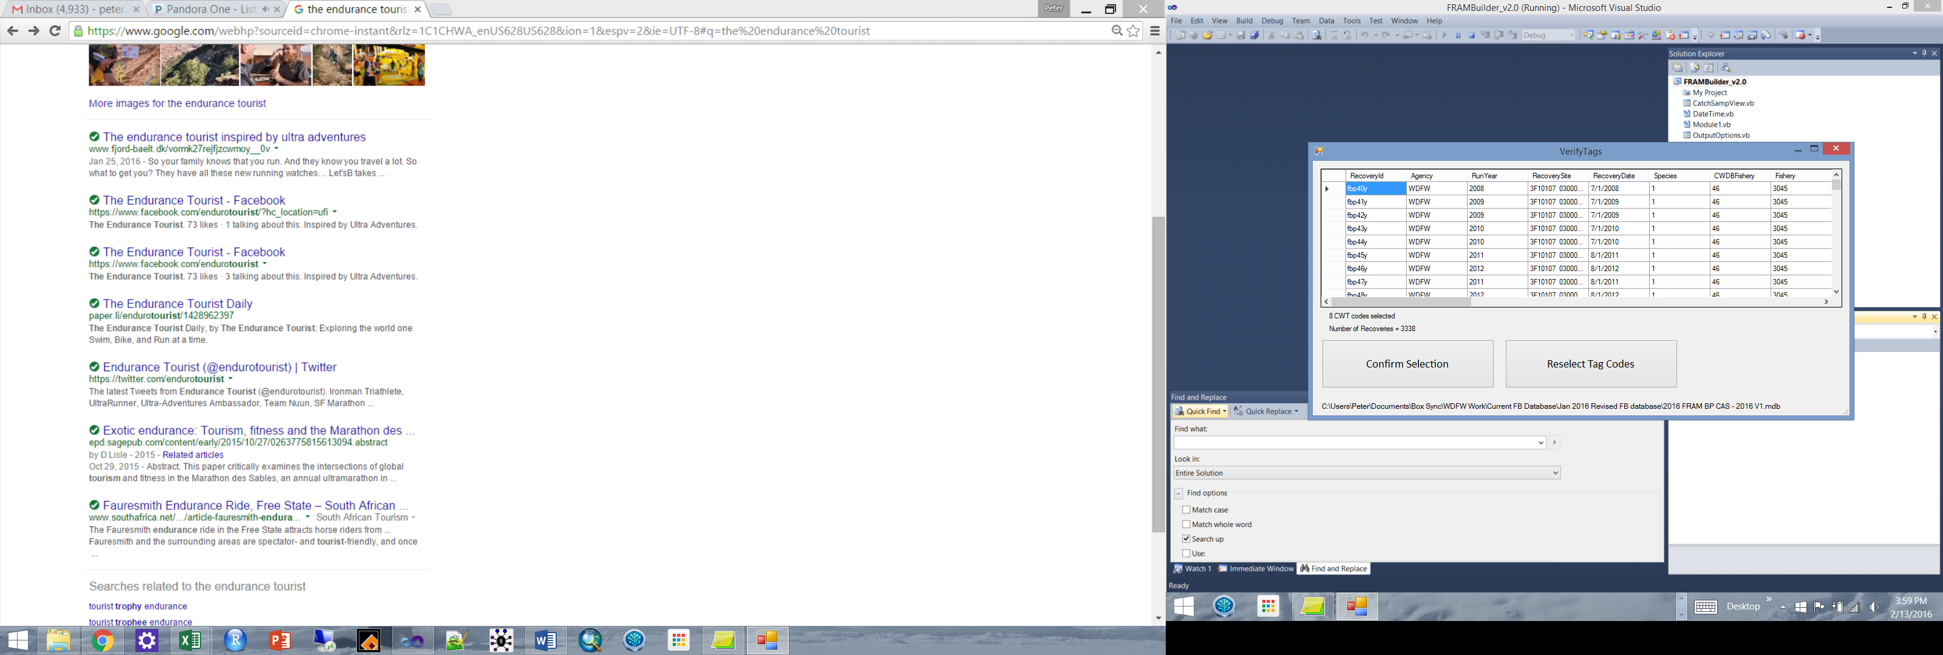

**Figure 8.3.** The view/verify codes screen, a quick stop between selecting codes and moving into processing the queued dataset. You can basically click ‘Confirm Selection’ as soon as you arrive here, or peruse data to your heart’s content.

Now you’re ready to set the specifications for the particular mapping and data processing/prep run, which you’ll do in the ‘Output Options’ form (Figure 8.4). For most runs, you’ll want to process things according to the defaults, which are already checked when the form loads. The output options include:

Merging and Mapping Options:

* ‘Create mapped table in DB’ [Default = True]. [note that this is in contrast to the old ‘*.CWT’ calibration file format, which can still be created using a disabled feature]
* ‘Merge Codes w/in BY’ [Default = True].
* ‘Merge Codes b/n BY’ [Default = True].
* ‘Use db wts + rules for w/in BY merge?’ [Default = False].

Output Format Options:

* ‘Write to database’ [Default = True].
* ‘Write to CWTAll table’ [Default = True].
* [INACTIVE] *.CWT text file. [this is the old calibration program’s preferred format]

Other Processing Options:

* ‘Include draft fisheries’ [Default = False].
* ‘Prepare length file too’ [Default = False].
* ‘Prepare length file ONLY’ [Default = False].

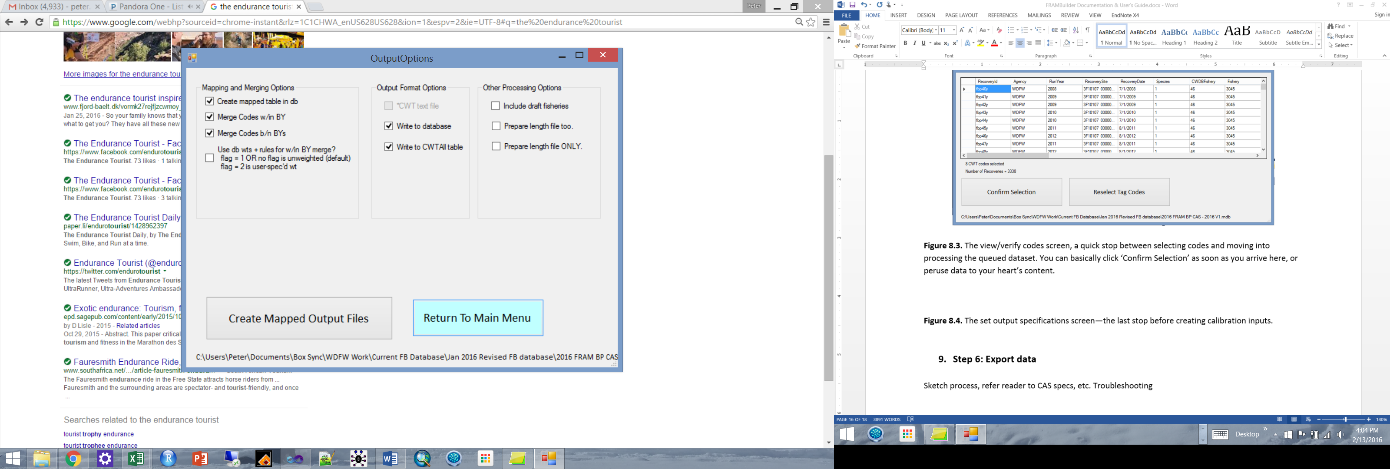

**Figure 8.4.** The set output specifications screen—the last stop before creating calibration inputs.

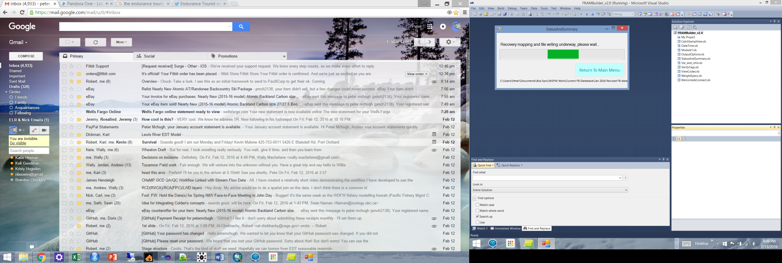

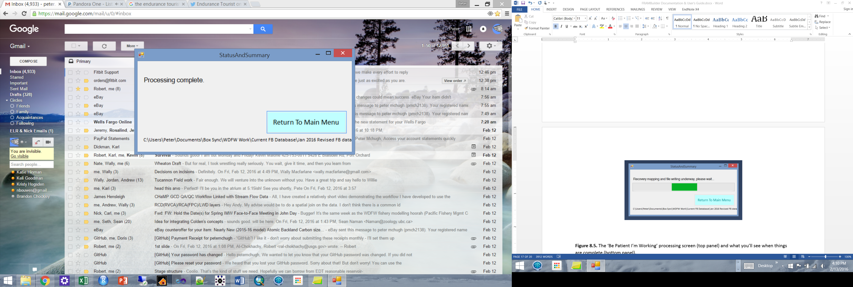

**Figure 8.5.** The ‘Be Patient I’m Working’ processing screen (top panel) and what you’ll see when things are complete (bottom panel).

1. **Step 6: Export data**

Sketch process, refer reader to CAS specs, etc. Troubleshooting

1. **Other FRAMBuilder functions/features**

Preparing data for analyzing growth…

1. **Limitations to FRAMBuilder and opportunities for enhancement**

Sketch process, refer reader to CAS specs, etc. Troubleshooting

**Appendix A. CTC Filter Database Recoveries Query Details/notes**

SELECT RECOVERIES.recovery_id, RECOVERIES.recovery_date, RECOVERIES.period_type, RECOVERIES.period, RECOVERIES.species, RECOVERIES.sex, RECOVERIES.length, RECOVERIES.length_code, RECOVERIES.tag_code, RECOVERIES.tag_status, RECOVERIES.estimation_level, RECOVERIES.recovery_location_code, RECOVERIES.fishery, RECOVERIES.estimated_number, RECOVERIES.sample_type, RECOVERIES.run_year, RECOVERIES.recorded_mark, RECOVERIES.catch_sample_id, RECOVERIES.detection_method, RECOVERIES.reporting_agency

FROM RECOVERIES INNER JOIN STKCDS ON RECOVERIES.tag_code = STKCDS.CODE

*### note, across all subsets, sample_type <> 5 excludes voluntary recoveries with no awareness*

WHERE ((((RECOVERIES.fishery)<"60") AND ((RECOVERIES.sample_type)<>"5") AND ((STKCDS.REGION) In ("WASH","COLUMBIA","OREGON")))

*## no high seas included for WA/ColR/OR ##*

OR

(((RECOVERIES.fishery)<"50") AND ((RECOVERIES.sample_type)<>"5") AND ((RECOVERIES.reporting_agency)="CDFO") AND ((STKCDS.REGION)="CANADA"))

*## no Canadian escapements (they’re entered as auxiliary) ##*

OR

(((RECOVERIES.fishery)<"49" Or (RECOVERIES.fishery)="94") AND ((RECOVERIES.sample_type)<>"5") AND ((RECOVERIES.reporting_agency) In ("ADFG","NMFS")) AND ((STKCDS.REGION)="ALASKA"))

*## For AK, include standard fisheries and marine trap (net) ##*

OR

(((RECOVERIES.fishery)<"60") AND ((RECOVERIES.sample_type)<>"5") AND ((RECOVERIES.reporting_agency)<>"CDFO") AND ((STKCDS.REGION)="CANADA"))

OR

(((RECOVERIES.fishery)<"70" Or (RECOVERIES.fishery)="94") AND ((RECOVERIES.sample_type)<>"5") AND ((RECOVERIES.reporting_agency) Not In ("ADFG","NMFS")) AND ((STKCDS.REGION)="ALASKA"))

OR

(((RECOVERIES.fishery)>="60" And (RECOVERIES.fishery)<"70") AND ((RECOVERIES.sample_type)<>"5") AND ((RECOVERIES.reporting_agency) Not In ("ADFG","NMFS","CDFO")) AND ((STKCDS.REGION)="CANADA"))

OR

(((RECOVERIES.fishery)>="60" And (RECOVERIES.fishery)<"70") AND ((RECOVERIES.sample_type)<>"5") AND ((RECOVERIES.reporting_agency) Not In ("ADFG","NMFS","CDFO")) AND ((STKCDS.REGION) In ("WASH","COLUMBIA","OREGON")))) and Left(RECOVERIES.recovery_location_code,5) <> "1M1DF";

**Appendix B. Overview of the FRAM-modified CAS database**

Sketch process, refer reader to CAS specs, etc. Troubleshooting

**Appendix C. Weighting algorithm for merging stocks within and across broods…**

Provide basic equations, etc.

**Appendix D. Notes and exceptions for specific stock and fishery processing**

e.g., ageing up by one year Willamette and CKL spring Chinook…origin is in the old FRAMBuilder program (Kurt Reidinger)

Create LCN auxiliaries as needed (i.e., over and above mapped FRAM-CAS CWT Recovery/Release content, there may be LRH or CWF auxiliary data too).

Need to recode fishery codes within auxiliaries to version of CAS (2013) upon which this workflow relies.

Need to provide user-supplied weights to the FRAM-CAS datable to merge yearling/fingerling groups into a single Skagit spring stock

For current manifestation of BP stock structure, need to duplicate SPY for LaWA, NF Nooksack spring fingerlings for SF, and Skagit summer/fall fingerlings for yearlings (no longer exists, but stock is there).

Need to populate field for recoveries in fishery 39 to have T/NT apportioning of unidentifiable recoveries (i.e., some are distinguishable as being from T or NT, but several are not)…here’s the comment from OutputOptions code:

'Thirteenth Rule: Separating Bellingham Bay Net Fishery Recoveries into their respective Treaty/Non-treaty components

'Note that this requires some pre-processing of data and manual manipulation of recoveries within the CAS database in order for it to work

'Specifically, you need to (1) add a field called 'Tr_NT' to the 'CWDBRecovery' table, if it hasn't been done already

'(2) populate it with 'Tr' and 'NT' values based on the Gear Codes which aren't in CAS (you must pair with raw RMIS recovery data)

'and (3) duplicate within the database any 'mixed' (indistinguishable Tr and NT recs) recoveries and

'and assign a fraction to each NT/Tr fisher types (e.g., using catch proportions for that run year). It's a kludge, but gets it done

1. The FRAM-CAS fishery crosswalk adheres strictly to the CTC’s ‘fine scale’ fishery strata from 2013; any attempt to create an updated FRAM-CAS database will require an updated FRAM to CTC crosswalk (database table ‘FRAM_Fishery’.
2. Because the CTC’s fine-scale fishery change routinely, it may be necessary to modify auxiliaries to revert to the 2013 convention before using; additionally.
3. The exact origin of this decrementing practice precedes FRAMBuilder 2.0 and only applies to these two yearling release stocks; if justified/desired, a similar adjustment could be applied for other yearling stocks.
4. Note that user-specified between BY merging hasn’t been fully tested/vetted, despite the capacity to do so.
5. Note that some brief post-processing steps are needed to create the full 38/76 stock structure (i.e., duplicate SPY for UWA; replicate NF Nooskack spring fingerlings for SF; duplicate Skagit fall fingerlings for yearlings).